
Module code and name: | Database Systems 5BUIS009C
Assessment: | CW 1
Student ID: | 00018919
Submission deadline: | 09/12/2025
Wordcount
Results date and type of feedback
Result (Pass or Fail)
Feedback

Contents:
- Step 1 – Case Study
- Step 2 – ER diagram using UML
- Step 3 – Relational DB diagram
- Step 4 – Functional dependencies and normalizations
- Step 5 – Create DB (SQL DDL)
- Step 6 – Populate table with sample data
- Step 7 – Delete scripts
- Step 8 – Users and roles
- Step 9 – Transactions, anomalies, and deadlocks
- Step 10 – No SQL implementation using MongoDB
- References

Detailed description of the task

Step 1: Case study

SunnySun Guesthouse is a small hotel with 24 rooms. It’s not a big place, so most things are handled manually, but they want to organise everything better. The rooms are divided into Standard, Deluxe and Suite types. Each room has a room number, floor, bed setup and a max number of guests. Every room belongs to only one type, and the room type usually decides the price (although sometimes the manager changes prices during busy seasons, which gets a bit confusing for staff).

Guests can book a room by phone, email or the website. When booking, they give their name, home address and one or more phone numbers. Some guests give two numbers because they don’t always pick up the first one. A reservation includes the room they want, check-in and check-out dates, how many adults/children, and special requests like early check-in or extra pillows. Some reservations require a deposit first, and sometimes guests forget to pay it on time, so receptionists have to remind them.

During their stay, guests may use different services like breakfast, laundry, airport pickup or spa treatments. Staff record these services with the date and time, but sometimes they note it on paper first and enter it later, which can cause mismatches in the final bill. These services are added to the reservation and shown during checkout.

All payments are recorded: deposits, full payments and even refunds. A payment includes the amount, method (cash, card or online) and payment date. If a guest cancels, the refund depends on the guesthouse rules, but the manager sometimes allows exceptions, especially for regular customers.

The hotel employs managers, receptionists and housekeepers. Receptionists handle bookings, payments and check-ins; housekeepers clean rooms and report issues; managers deal with serious problems and approve refunds. When something breaks in a room (like a light or shower), a maintenance request is created. It includes the room, the problem, the date and the staff member working on it.

When the guest checks out, the receptionist prepares an invoice that includes the room cost, services used, taxes, payments already made and the remaining balance. Guests can leave feedback, but not everyone fills it out, especially when they’re in a hurry.

Step 2: ER diagram

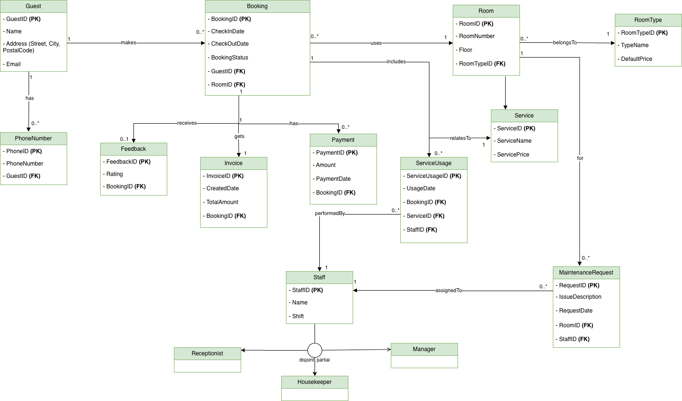
Figure 1: ER diagram

STEP 3: Relational DB diagram

EER diagram relational scheme

Guest
GuestID (PK), Name, Street, City, PostalCode, Email

PhoneNumber
PhoneID (PK), PhoneNumber, GuestID (FK)

Booking
BookingID (PK), CheckInDate, CheckOutDate, BookingStatus, GuestID (FK), RoomID (FK)

Room
RoomID (PK), RoomNumber, Floor, RoomTypeID (FK)

RoomType
RoomTypeID (PK), TypeName, DefaultPrice

Payment
PaymentID (PK), Amount, PaymentDate, BookingID (FK)

Invoice
InvoiceID (PK), CreatedDate, TotalAmount, BookingID (FK, UNIQUE)

Feedback
FeedbackID (PK), Rating, BookingID (FK, UNIQUE)

Service
ServiceID (PK), ServiceName, ServicePrice

ServiceUsage
ServiceUsageID (PK), UsageDate, BookingID (FK), ServiceID (FK), StaffID (FK)

Staff
StaffID (PK), Name, Shift

Receptionist
StaffID (PK, FK → Staff)

Housekeeper
StaffID (PK, FK → Staff)

Manager
StaffID (PK, FK → Staff)

MaintenanceRequest
RequestID (PK), IssueDescription, RequestDate, RoomID (FK), StaffID (FK)

The Enhanced ER model was mapped to a relational schema using the standard rules from the lectures. Each strong entity became its own table with a primary key. The composite attribute Address was split into three separate attributes: Street, City, and PostalCode. The multivalued attribute PhoneNumber was stored in a separate table that includes a foreign key pointing to the Guest table.

For the Staff hierarchy, I used the table-per-subclass approach. Separate tables were created for Receptionist, Housekeeper, and Manager, and each of these tables references the primary key from the Staff table. The relationship entity ServiceUsage was also implemented as its own table with a primary key and foreign keys linking to the related entities.

The final relational schema was implemented in Microsoft SQL Server Management Studio. Because the full diagram didn’t fit clearly on one screen, I split it into three sections to make it easier to read.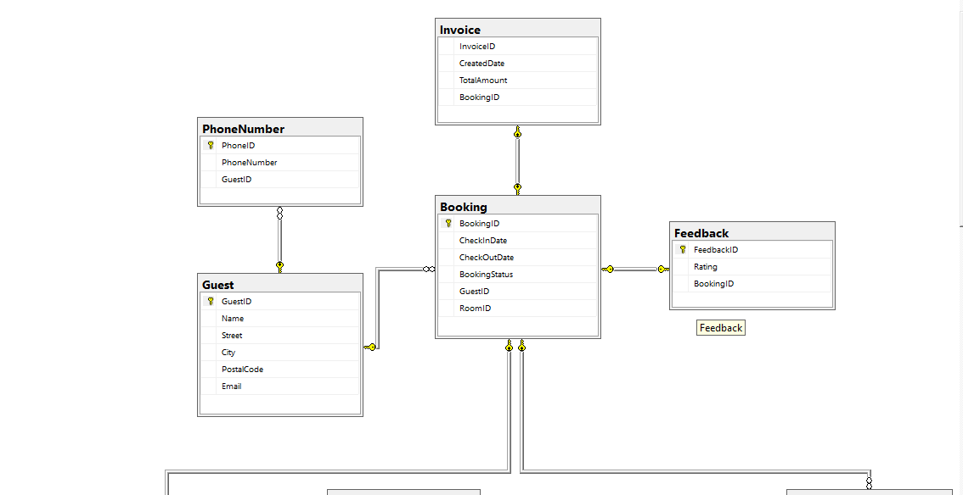
Figure 2.1: SQL server relational diagram part1
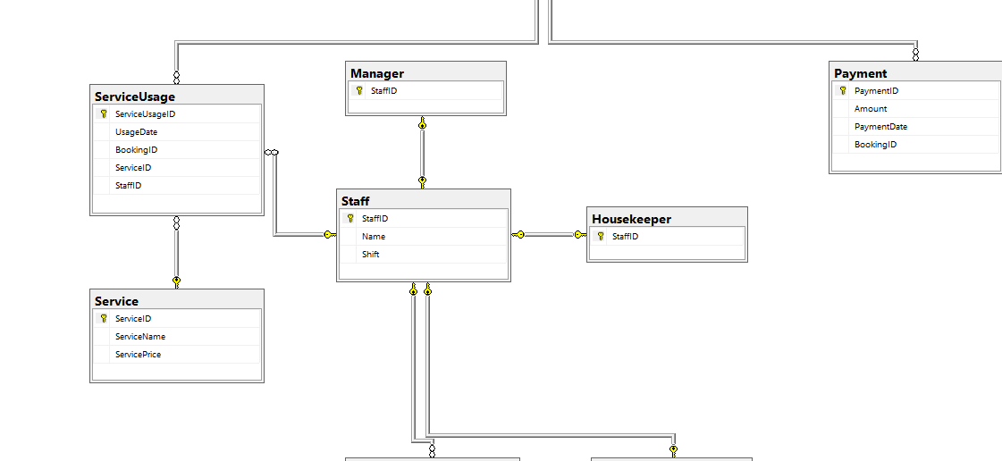
Figure 2.2: SQL server relational diagram part2
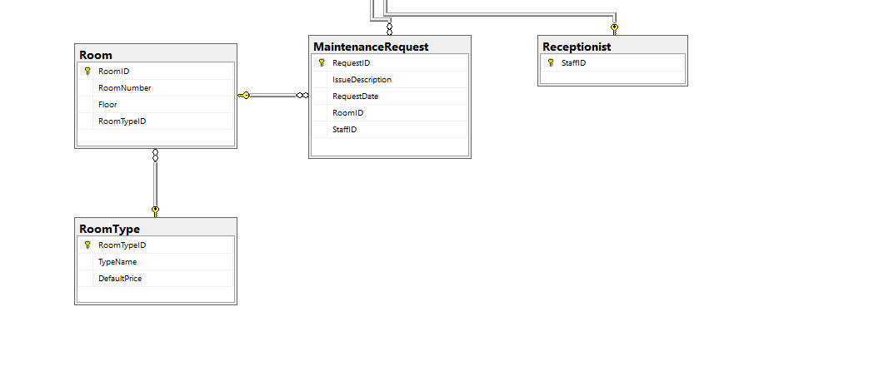
Figure 2.3: SQL server relational diagram part3

Step 4: Functional Dependencies and Normalization
In this section I reviewed the functional dependencies in my relational schema and selected one table that was not in Third Normal Form. The Room table was the best example because it originally combined attributes describing the individual room with attributes describing the room type. This created a transitive dependency.

Before normalization, the Room table was:

Room(RoomID, RoomNumber, Floor, TypeName, DefaultPrice)

From this structure, the following functional dependencies hold:
- RoomID => RoomNumber, Floor, TypeName, DefaultPrice
- TypeName => DefaultPrice

The second dependency shows that DefaultPrice depends on the room type, not on the room itself.

3NF Violation
Because:

TypeName => DefaultPrice

we get a transitive dependency:

RoomID => TypeName => DefaultPrice

This violates 3NF because DefaultPrice is not directly dependent on the primary key of the Room table.

Normalization to 3NF

To resolve the violation, I separated the room type attributes into a new relation. After normalization, the schema becomes:

Room(RoomID, RoomNumber, Floor, RoomTypeID)
RoomType(RoomTypeID, TypeName, DefaultPrice)

The RoomType table now stores all attributes related to each category of room, and the Room table only references it through RoomTypeID. With this structure, every non-key attribute depends directly on the primary key of its own table, so both relations satisfy the requirements of Third Normal Form.

Step 5: Create table (SQL DDL)

In this step I created all tables for the hotel reservation system using SQL Server. The relational schema from Step 3 was used as the blueprint, and each table was defined with appropriate data types, primary keys, and foreign key constraints. For the one-to-one relationships (Booking–Invoice and Booking–Feedback), I added UNIQUE constraints to ensure that each booking can be linked to only one invoice and one feedback record.

The inheritance between Staff and its subclasses was implemented using the table-per-subclass approach, which required creating separate tables for each subclass and linking them back to Staff through their primary keys.

All tables were created successfully in SQL Server, and no errors were reported during the creation process.

CREATE TABLE Guest (
GuestID INT IDENTITY(1,1) PRIMARY KEY,
Name NVARCHAR(100) NOT NULL,
Street NVARCHAR(100) NOT NULL,
City NVARCHAR(100) NOT NULL,
PostalCode NVARCHAR(20) NOT NULL,
Email NVARCHAR(100)
);
GO

CREATE TABLE PhoneNumber (
PhoneID INT IDENTITY(1,1) PRIMARY KEY,
PhoneNumber NVARCHAR(20) NOT NULL,
GuestID INT NOT NULL,
FOREIGN KEY (GuestID) REFERENCES Guest(GuestID)
);
GO

CREATE TABLE RoomType (
RoomTypeID INT IDENTITY(1,1) PRIMARY KEY,
TypeName NVARCHAR(50) NOT NULL,
DefaultPrice DECIMAL(10,2) NOT NULL
);
GO

CREATE TABLE Room (
RoomID INT IDENTITY(1,1) PRIMARY KEY,
RoomNumber NVARCHAR(10) NOT NULL,
Floor INT NOT NULL,
RoomTypeID INT NOT NULL,
FOREIGN KEY (RoomTypeID) REFERENCES RoomType(RoomTypeID)
);
GO

CREATE TABLE Booking (
BookingID INT IDENTITY(1,1) PRIMARY KEY,
CheckInDate DATE NOT NULL,
CheckOutDate DATE NOT NULL,
BookingStatus NVARCHAR(50) NOT NULL,
GuestID INT NOT NULL,
RoomID INT NOT NULL,
FOREIGN KEY (GuestID) REFERENCES Guest(GuestID),
FOREIGN KEY (RoomID) REFERENCES Room(RoomID)
);
GO

CREATE TABLE Payment (
PaymentID INT IDENTITY(1,1) PRIMARY KEY,
Amount DECIMAL(10,2) NOT NULL,
PaymentDate DATE NOT NULL,
BookingID INT NOT NULL,
FOREIGN KEY (BookingID) REFERENCES Booking(BookingID)
);
GO

CREATE TABLE Invoice (
InvoiceID INT IDENTITY(1,1) PRIMARY KEY,
CreatedDate DATE NOT NULL,
TotalAmount DECIMAL(10,2) NOT NULL,
BookingID INT NOT NULL UNIQUE,
FOREIGN KEY (BookingID) REFERENCES Booking(BookingID)
);
GO

CREATE TABLE Feedback (
FeedbackID INT IDENTITY(1,1) PRIMARY KEY,
Rating INT CHECK (Rating BETWEEN 1 AND 5),
BookingID INT NOT NULL UNIQUE,
FOREIGN KEY (BookingID) REFERENCES Booking(BookingID)
);
GO

CREATE TABLE Service (
ServiceID INT IDENTITY(1,1) PRIMARY KEY,
ServiceName NVARCHAR(100) NOT NULL,
ServicePrice DECIMAL(10,2) NOT NULL
);
GO

CREATE TABLE Staff (
StaffID INT IDENTITY(1,1) PRIMARY KEY,
Name NVARCHAR(100) NOT NULL,
Shift NVARCHAR(50) NOT NULL
);
GO

CREATE TABLE Receptionist (
StaffID INT PRIMARY KEY,
FOREIGN KEY (StaffID) REFERENCES Staff(StaffID)
);
GO

CREATE TABLE Housekeeper (
StaffID INT PRIMARY KEY,
FOREIGN KEY (StaffID) REFERENCES Staff(StaffID)
);
GO

CREATE TABLE Manager (
StaffID INT PRIMARY KEY,
FOREIGN KEY (StaffID) REFERENCES Staff(StaffID)
);
GO

CREATE TABLE ServiceUsage (
ServiceUsageID INT IDENTITY(1,1) PRIMARY KEY,
UsageDate DATE NOT NULL,
BookingID INT NOT NULL,
ServiceID INT NOT NULL,
StaffID INT NOT NULL,
FOREIGN KEY (BookingID) REFERENCES Booking(BookingID),
FOREIGN KEY (ServiceID) REFERENCES Service(ServiceID),
FOREIGN KEY (StaffID) REFERENCES Staff(StaffID)
);
GO

CREATE TABLE MaintenanceRequest (
RequestID INT IDENTITY(1,1) PRIMARY KEY,
IssueDescription NVARCHAR(200) NOT NULL,
RequestDate DATE NOT NULL,
RoomID INT NOT NULL,
StaffID INT NOT NULL,
FOREIGN KEY (RoomID) REFERENCES Room(RoomID),
FOREIGN KEY (StaffID) REFERENCES Staff(StaffID)
);
GO

Step 6: Populate table with sample data

After creating the tables, I inserted sample data using INSERT INTO statements. All rows were added successfully, and no constraint errors occurred. The data covers all main entities, including Guest, Room, Booking, Payment, Invoice, Feedback, Staff, and ServiceUsage.

The inserted records show that the foreign key relationships work correctly. For example, every BookingID used in Payment, Invoice, and Feedback exists in the Booking table, and every StaffID used in the subclass tables appears in Staff. The screenshots below show populated tables such as Guest, Room, Booking, Payment, and ServiceUsage.

insert into Guest (Name, Street, City, PostalCode, Email) values
('Ali Karimov', 'Yunusabad 7', 'Tashkent', '100093', 'ali.karimov@mail.com'),
('Dilnoza Akhmedova', 'Chilonzor 9', 'Tashkent', '100115', 'dilnoza@mail.com'),
('Sardor Rakhmonov', 'Shaykhontohur 14', 'Tashkent', '100120', 'sardor.r@mail.com'),
('Malika Davronova', 'Amir Temur 32', 'Samarkand', '140100', 'malika.d@example.com'),
('Javlon Sobirov', 'Navoiy 11', 'Bukhara', '200100', 'javlon_s@example.com'),
('Aziza Kodirova', 'Fergana Yangi Shahar 5', 'Fergana', '150100', 'aziza.k@example.com'),
('Sherzod Murodov', 'Zarafshan 4', 'Navoi', '210100', 'sher.m@example.com');

insert into PhoneNumber (PhoneNumber, GuestID) values
('+998901234567', 1),
('+998909876543', 1),
('+998933210987', 2),
('+998977001122', 3),
('+998935551122', 4),
('+998907700221', 5),
('+998933344556', 6),
('+998998887766', 7);

insert into RoomType (TypeName, DefaultPrice) values
('Standard', 350000),
('Deluxe', 750000),
('Family Suite', 980000),
('Economy', 250000);

insert into Room (RoomNumber, Floor, RoomTypeID) values
('101', 1, 1),
('102', 1, 2),
('103', 1, 4),
('201', 2, 1),
('202', 2, 3),
('203', 2, 2),
('301', 3, 3),
('302', 3, 2);

insert into Booking (CheckInDate, CheckOutDate, BookingStatus, GuestID, RoomID) values
('2024-11-10', '2024-11-12', 'Completed', 1, 1),
('2024-12-01', '2024-12-05', 'Completed', 2, 2),
('2025-01-15', '2025-01-18', 'Completed', 3, 5),
('2025-02-02', '2025-02-04', 'Cancelled', 4, 3),
('2025-03-20', '2025-03-22', 'Completed', 5, 4),
('2025-04-10', '2025-04-15', 'In Progress', 6, 6),
('2025-05-01', '2025-05-03', 'Completed', 7, 7);

insert into Payment (Amount, PaymentDate, BookingID) values
(700000, '2024-11-10', 1),
(3000000, '2024-12-01', 2),
(2800000, '2025-01-15', 3),
(0, '2025-02-02', 4),
(700000, '2025-03-20', 5),
(3750000, '2025-04-10', 6),
(980000, '2025-05-01', 7);

insert into Invoice (CreatedDate, TotalAmount, BookingID) values
('2024-11-12', 700000, 1),
('2024-12-05', 3000000, 2),
('2025-01-18', 2800000, 3),
('2025-02-04', 0, 4),
('2025-03-22', 700000, 5),
('2025-04-15', 3750000, 6),
('2025-05-03', 980000, 7);

insert into Feedback (Rating, BookingID) values
(5, 1),
(4, 2),
(3, 3),
(4, 5),
(5, 7);

insert into Service (ServiceName, ServicePrice) values
('Laundry', 40000),
('Breakfast', 60000),
('Airport Pickup', 150000),
('Extra Bed', 80000),
('Room Cleaning', 30000);

insert into ServiceUsage (UsageDate, BookingID, ServiceID, StaffID) values
('2024-11-10', 1, 1, 3), -- Laundry by housekeeper
('2024-12-02', 2, 2, 1), -- Breakfast handled by receptionist
('2025-01-16', 3, 5, 3), -- Cleaning by housekeeper
('2025-03-20', 5, 3, 2), -- Airport pickup by manager
('2025-04-11', 6, 4, 1); -- Extra bed handled by receptionist

insert into Staff (Name, Shift) values
('Kamila Yusufova', 'Morning'),
('Bekzod Akromov', 'Night'),
('Dilshod Mamadaliyev', 'Morning'),
('Zarina Rasulova', 'Evening'),
('Ulugbek Nasrullaev', 'Morning');

insert into Receptionist (StaffID) values (1), (4);

insert into Housekeeper (StaffID) values (3), (5);

insert into Manager (StaffID) values (2);

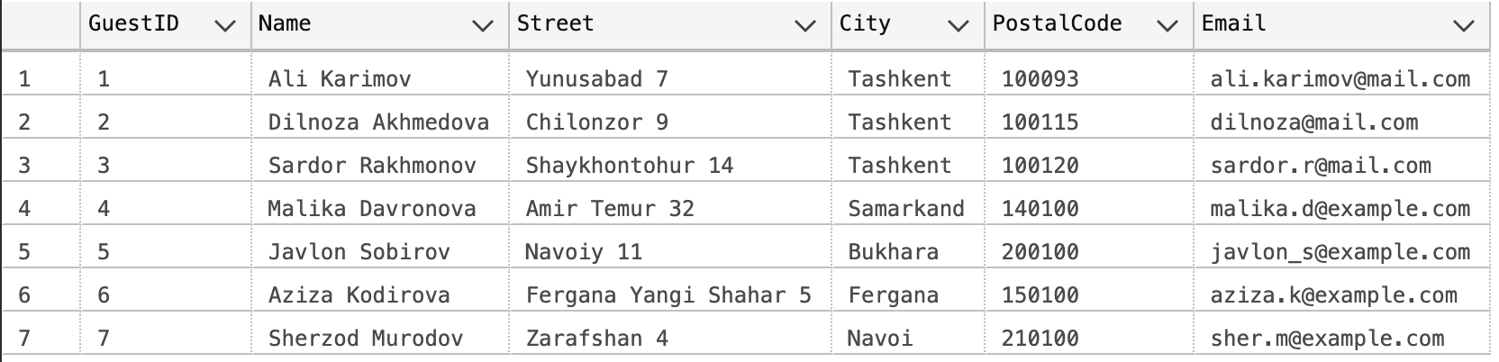
Figure 3: Sample data of Guest table
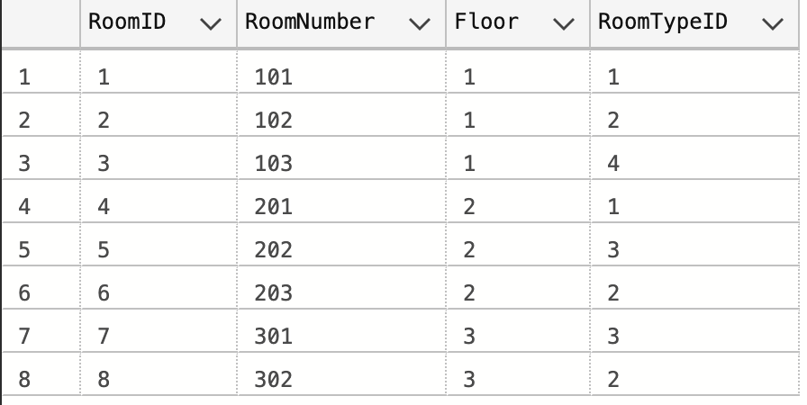
Figure 4: Sample data of Room table
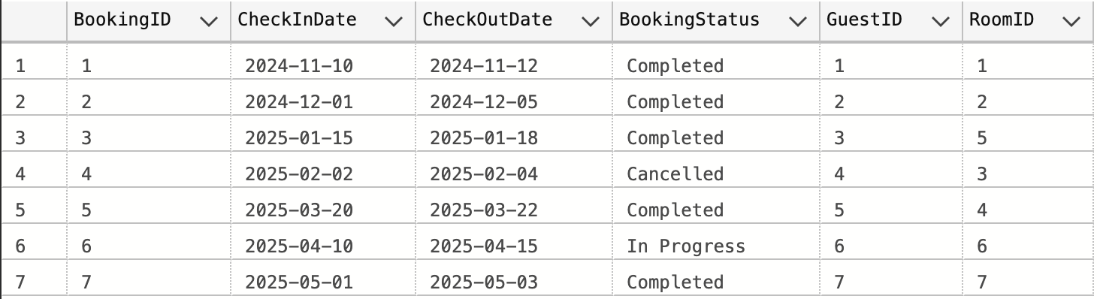
Figure 5: Sample data of Booking table

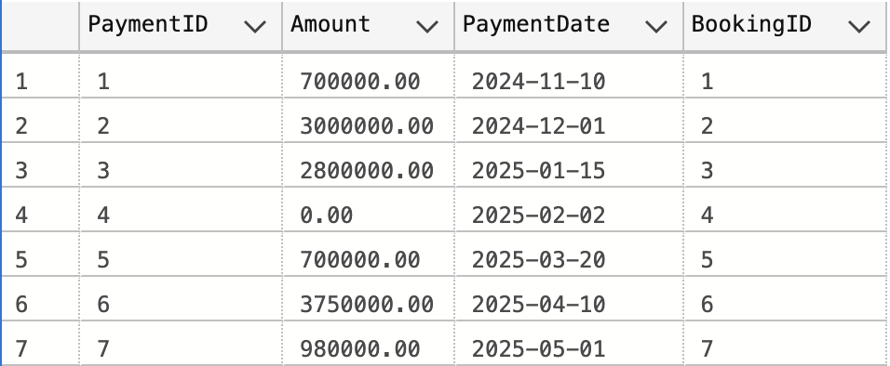
Figure 6: Sample data of Payment table

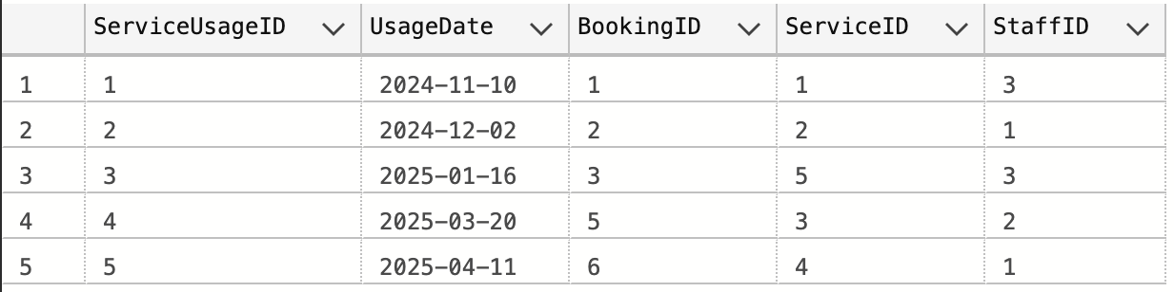
Figure 7: Sample data of ServiceUsage table

Step 7: Delete Script

To show that I understand how the foreign key relationships work in my database, I wrote a delete script that removes a booking together with all records that depend on it. A booking cannot be deleted on its own because it is linked to rows in ServiceUsage, Feedback, Invoice, and Payment. I deleted the child rows first and then removed the booking. This avoids foreign key errors and keeps the database in a consistent state.

delete from ServiceUsage
where BookingID =3;

delete from Feedback
where BookingID =3;

delete from Invoice
where BookingID =3;

delete from Payment
where BookingID =3;

delete from Booking
where BookingID =3;

The screenshot below shows that BookingID 3 and all related records were removed successfully, confirming that the script works as expected.

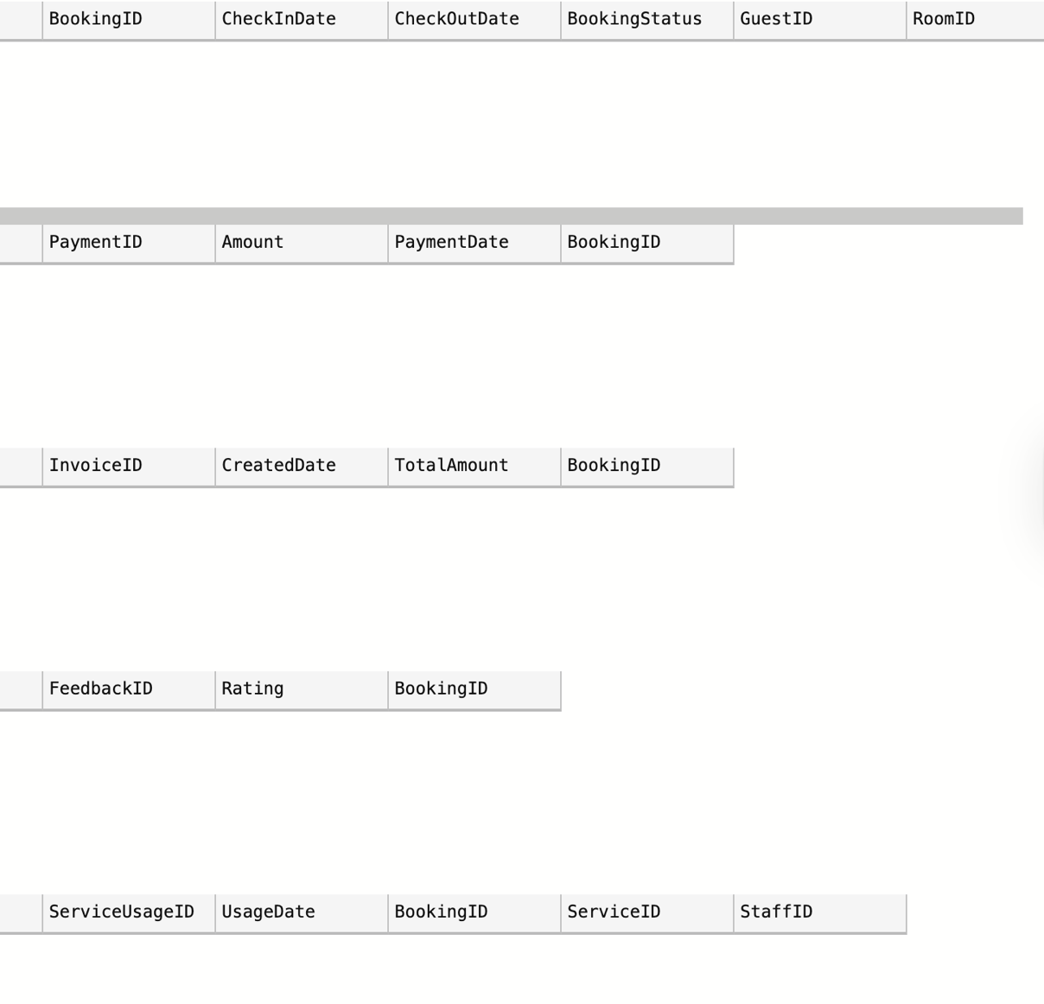
Figure 8: Empty result sets showing that BookingID 3 and all its dependent records were successfully deleted

Step 8: Users and roles

In this step, I implemented database security by creating logins, users, and roles in SQL Server (Anna, 2024). I set up three roles that match different activities in my hotel reservation system: reporting, data importing, and application access. Each role was given only the permissions it needs, following the least-privilege principle. Permissions were assigned to the roles instead of directly to users so the system is easier to manage later.

Reporting role (read-only access)
This role is designed for users who only need to view the data. They can run SELECT queries on the main tables but cannot modify anything.

CREATE LOGIN reportingUser WITH PASSWORD = 'ReportUser123!';
CREATE USER reportingUser FOR LOGIN reportingUser;
CREATE ROLE ReportingRole;

GRANT SELECT ON Guest TO ReportingRole;
GRANT SELECT ON Room TO ReportingRole;
GRANT SELECT ON RoomType TO ReportingRole;
GRANT SELECT ON Booking TO ReportingRole;
GRANT SELECT ON Payment TO ReportingRole;
GRANT SELECT ON Invoice TO ReportingRole;

ALTER ROLE ReportingRole ADD MEMBER reportingUser;

Data Importer role (read/write access to specific tables)
This role is intended for users who work with operational data, such as adding new guests or updating room details. They can insert and update records in selected tables, but they do not have permission to modify bookings, payments, or other sensitive tables. This keeps the system safe while still allowing the import process to function normally.
CREATE LOGIN dataImporter WITH PASSWORD = 'ImportData123!';
CREATE USER dataImporter FOR LOGIN dataImporter;
CREATE ROLE DataImporterRole;

GRANT SELECT, INSERT, UPDATE ON Guest TO DataImporterRole;
GRANT SELECT, INSERT, UPDATE ON Room TO DataImporterRole;
GRANT SELECT, INSERT, UPDATE ON Service TO DataImporterRole;
GRANT SELECT, INSERT, UPDATE ON Payment TO DataImporterRole;

ALTER ROLE DataImporterRole ADD MEMBER dataImporter;

Application role (writes bookings, feedback, and payments)
This role represents the permissions required by the hotel’s application layer. It can insert new bookings, create invoices and payments, and record feedback from guests. The role does not have access to administrative tables such as Staff or RoomType.

CREATE LOGIN appUser WITH PASSWORD = 'ApplicationUser123!';
CREATE USER appUser FOR LOGIN appUser;
CREATE ROLE ApplicationRole;

GRANT INSERT, SELECT ON Booking TO ApplicationRole;
GRANT INSERT, SELECT ON Payment TO ApplicationRole;
GRANT INSERT, SELECT ON Feedback TO ApplicationRole;
GRANT INSERT, SELECT ON ServiceUsage TO ApplicationRole;

GRANT SELECT ON Guest TO ApplicationRole;
GRANT SELECT ON Room TO ApplicationRole;
GRANT SELECT ON RoomType TO ApplicationRole;
GRANT SELECT ON Service TO ApplicationRole;

ALTER ROLE ApplicationRole ADD MEMBER appUser;

The screenshot below shows that all users and roles were created successfully.
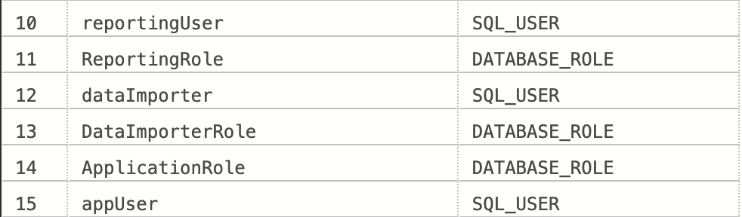
Figure 9: Database roles and users created successfully

Step 9: Transactions, anomalies, and deadlocks

Activity 1:

SET XACT_ABORT ON;

BEGIN TRANSACTION;

BEGIN TRY
select RoomID from Room where RoomID = 4;

insert into Booking (CheckInDate, CheckOutDate, BookingStatus, GuestID, RoomID)
values ('2025-06-10','2025-06-12','Confirmed', 2, 4);

declare @bID int = SCOPE_IDENTITY();
insert into Payment (Amount, PaymentDate, BookingID)
values (750000, GETDATE(), @bID);

insert into Invoice (CreatedDate, TotalAmount, BookingID)
values (GETDATE(), 750000, @bID);

COMMIT TRANSACTION;
print 'Transaction committed (Activity A)';
END TRY
BEGIN CATCH
ROLLBACK TRANSACTION;
print 'Transaction rolled back (Activity A)';
END CATCH;

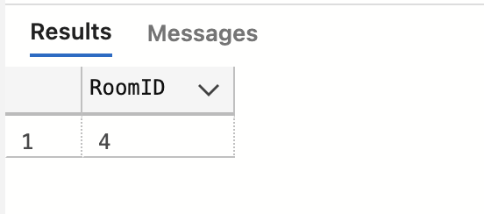
Figure 10: result of command of Activity 1
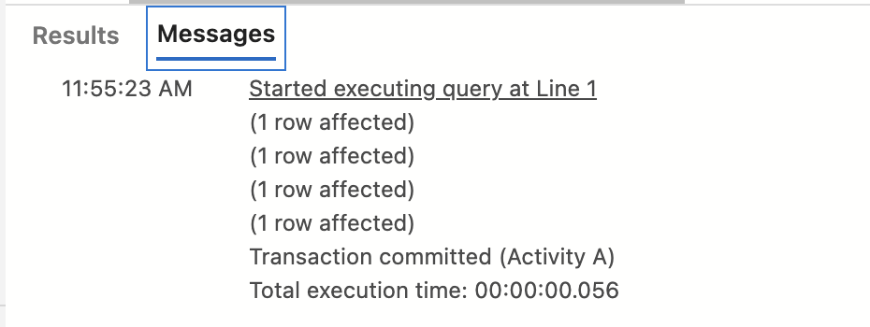
Figure 11: The message which is written with 'print' to show our command works successfully for Task A

To verify that are new data records are inserted correctly, this command was run;

select * from Booking order by BookingID desc;
select * from Payment order by PaymentID desc;
select * from Invoice order by InvoiceID desc;

And here are the results:

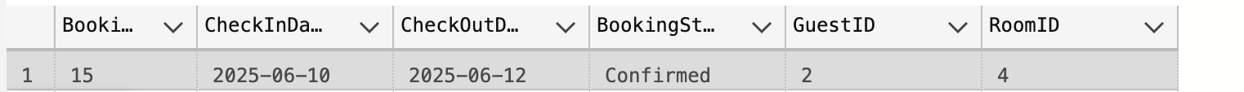
Figure 12: The booking is created with the details as we entered for room number 4

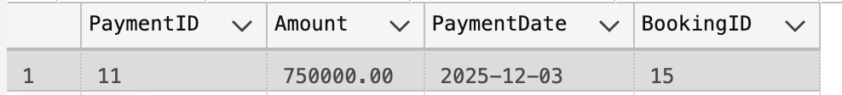
Figure 13: Payment for that room with Booking ID 15

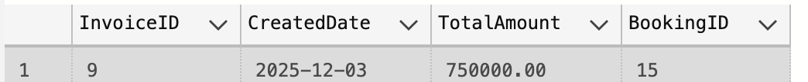
Figure 14: Invoice creation for Booking ID 15

Transaction Schedule (T1)
1. R(Room.RoomID) – check room
2. W(Booking) – insert booking
3. W(Payment) – insert payment
4. W(Invoice) – insert invoice
5. Commit

Isolation Level: READ COMMITTED

This isolation level prevents dirty reads while still keeping good concurrency. It works well for this activity because the operations are mostly inserts and do not require stronger locking.

Activity 2:

SET XACT_ABORT ON;

BEGIN TRANSACTION;

BEGIN TRY

select ServiceID
from Service
where ServiceID = 3;

select BookingID
from Booking
where BookingID = 10;

insert into ServiceUsage (UsageDate, BookingID, ServiceID, StaffID)
values (GETDATE(), 10, 3, 2);

COMMIT TRANSACTION;
print 'Transaction committed (Activity B)';
END TRY
BEGIN CATCH
ROLLBACK TRANSACTION;
print 'Transaction rolled back (Activity B)';
END CATCH;

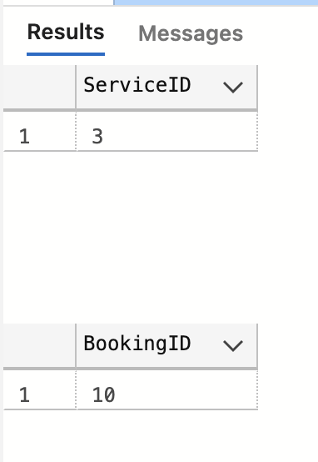
Figure 15: result of transaction command for Activity 2
select * from ServiceUsage order by ServiceUsageID desc;

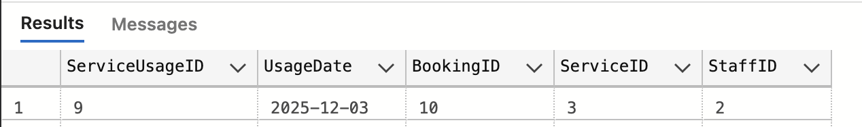
Figure 16: Result of the last SELECT command

Transaction Schedule (T2)
1. R(Service.ServiceID) – check service
2. R(Booking.BookingID) – check booking
3. W(ServiceUsage) – insert usage entry
4. Commit – finish transaction

Isolation Level: READ COMMITTED

It prevents reading uncommitted rows and keeps concurrency high. This task does not require serializable-level strictness, so READ COMMITTED is the best choice.

Lost Update Demonstration
Session 1
We run this command:

select * from Invoice where BookingID = 2;

Before lost update we had this total amount:

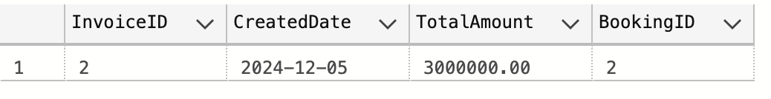

In Window A we run this:

SET TRANSACTION ISOLATION LEVEL READ COMMITTED;

BEGIN TRAN;
declare @old decimal(10,2);

select @old = TotalAmount
from Invoice
where BookingID = 2;

WAITFOR DELAY '00:00:02';

update Invoice
set TotalAmount = @old + 30000
where BookingID = 2;
commit;

In Window B we run this:

SET TRANSACTION ISOLATION LEVEL READ COMMITTED;

BEGIN TRAN;

declare @old decimal(10,2);

select @old = TotalAmount
from Invoice
where BookingID = 2;

WAITFOR DELAY '00:00:02';

update Invoice
set TotalAmount = @old + 30000
where BookingID = 2;

commit;

To check the result, we again run this:

select * from Invoice where BookingID = 2;

And the result is:
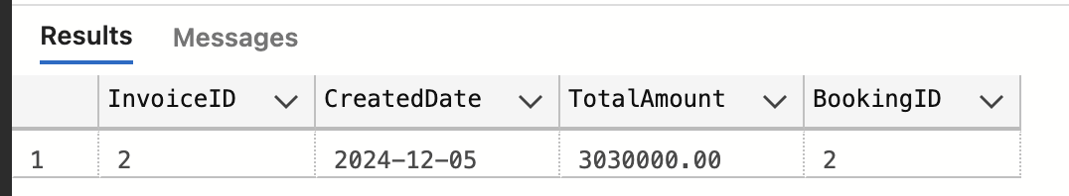

Both sessions read the same old value, calculate a new one, and update the row. Only the last commit stays in the table, meaning the first update is overwritten (GeeksforGeeks, 2019).

Inconsistent Analysis

In my case study, this can happen if one session is calculating the total money earned from invoices, while another session is inserting a new invoice during the calculation.

In Window A we run this:

SET TRANSACTION ISOLATION LEVEL READ COMMITTED;

BEGIN TRAN;

select SUM(TotalAmount) as Total1
from Invoice;

WAITFOR DELAY '00:00:05';

select SUM(TotalAmount) as Total2
from Invoice;

commit;

During delay we run this in Window B:

insert into Invoice (CreatedDate, TotalAmount, BookingID)
values (GETDATE(), 50000, 8);

In the results tab of Window A we see these two results:

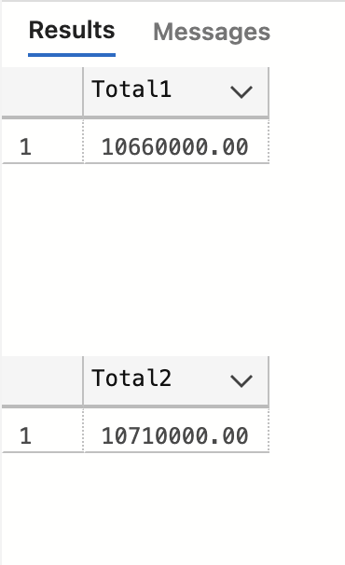
Figure 17: Inconsistent analysis showing different totals inside the same transaction

During this test, Session A calculated the total amount from the Invoice table twice inside the same transaction. While it was waiting, Session B inserted a new invoice. Since the isolation level was READ COMMITTED, Session A could see the new committed row in the second calculation. This caused the two totals to be different, which shows the inconsistent analysis anomaly.

Deadlock

In Window A we run:

BEGIN TRAN;

update Booking
set BookingStatus = 'Updating T1'
where BookingID = 2;

WAITFOR DELAY '00:00:05';

update Payment
set Amount = Amount + 10
where PaymentID = 2;

In Window B we run:

BEGIN TRAN;

update Payment
set Amount = Amount + 20
where PaymentID = 2;

WAITFOR DELAY '00:00:05';

update Booking
set BookingStatus = 'Updated by T2'
where BookingID = 2;

As a result, it will show this message:

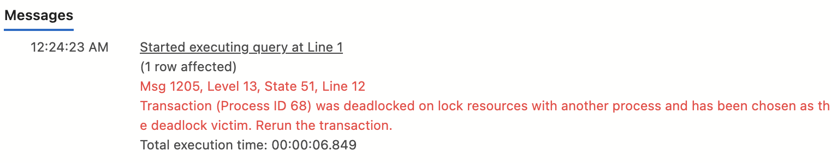

Because one transaction is rolled back, the other completes

When I run one more time after the first one is completed, it runs successfully

Deadlock transaction schedule:

Step | T1 | T2
1 | W (BookingID=2)
2 |  | W(PaymentID=2)
3 | T1 waits for Payment
4 |  | T2 waits for Booking
5 | Deadlock detected | Deadlock detected

I used Azure Studio during my project with Mac, which is why I couldn’t visually show the deadlock. But as I understand, a deadlock looks like:

T1waits for T2
T2 waits for T1

And this is the deadlock cycle.

How to avoid deadlocks?

To avoid deadlocks in this system, transactions should follow the same order when updating related tables. For example, if the application always updates the Booking table first and then the Payment table, the circular wait cannot happen. It also helps to keep transactions short so that locks are released quickly. If a deadlock still occurs, the transaction can simply be retried. In real applications, long delays inside transactions should be avoided because they increase the chance of blocking and deadlocks (GeeksforGeeks, 2017).

Step 10: No SQL Implementation using MongoDB

For this part, I implemented a NoSQL solution using MongoDB. I chose the Reviews (guest feedback) feature because it naturally fits a document model. Each review can be stored as one document with the guest, booking, rating, and comments together, making the structure simple and flexible.

Since this cannot be done in Azure Data Studio, I installed MongoDB locally (mongodb-macos-aarch64-8.2.2) and worked from the terminal. I created a data directory and started the server with:
mongod --dbpath ~/mongodb-data.

In a second terminal window, I opened the MongoDB shell:
test> mongosh
test> use HotelDB
switched to db HotelDB

I then created collections that match the logical parts of the hotel system:

HotelDB> db.createCollection("guests")
{ ok: 1 }
HotelDB> db.createCollection("rooms")
{ ok: 1 }
HotelDB> db.createCollection("bookings")
{ ok: 1 }
HotelDB> db.createCollection("payments")
{ ok: 1 }
HotelDB> db.createCollection("serviceUsage")
{ ok: 1 }

After the collections were created, I inserted a few example documents. MongoDB returned acknowledged: true for each operation, which simply confirms that the insert worked
HotelDB> db.guests.insertMany([
... {
... guestID: 1,
... name: "Alice Johnson",
... city: "Tashkent",
... email: "alice@example.com",
... phones: ["+998901234567"]
... },
... {
... guestID: 2,
... name: "Bob Smith",
... city: "Samarkand",
... email: "bob@example.com",
... phones: ["+998931112233", "+998901112233"]
... }
... ])
{
acknowledged: true,
insertedIds: {
'0': ObjectId('6935edea8b41b73c2c9f7f5f'),
'1': ObjectId('6935edea8b41b73c2c9f7f60')
}
}
HotelDB> db.rooms.insertMany([
... { roomID: 1, type: "Standard", price: 350000 },
... { roomID: 2, type: "Deluxe", price: 500000 }
... ])
{
acknowledged: true,
insertedIds: {
'0': ObjectId('6935edec8b41b73c2c9f7f61'),
'1': ObjectId('6935edec8b41b73c2c9f7f62')
}
}
HotelDB> db.bookings.insertOne({
... bookingID: 10,
... guestID: 2,
... roomID: 2,
... checkIn: "2025-06-10",
... checkOut: "2025-06-12",
... status: "Confirmed"
... })
{
acknowledged: true,
insertedId: ObjectId('6935edf38b41b73c2c9f7f63')
}
HotelDB> db.payments.insertOne({
... paymentID: 1,
... bookingID: 10,
... amount: 750000,
... date: "2025-06-10"
... })
{
acknowledged: true,
insertedId: ObjectId('6935edf78b41b73c2c9f7f64')
}
HotelDB> db.serviceUsage.insertOne({
... usageID: 1,
... bookingID: 10,
... serviceName: "Room Cleaning",
... staffID: 2,
... date: "2025-06-11"
... })
{
acknowledged: true,
insertedId: ObjectId('6935edfc8b41b73c2c9f7f65')
}

I ran a few basic queries to check how the data can be viewed and manipulated.
This query lists all guests, and the output is shown below.

HotelDB> db.guests.find()
[
{
_id: ObjectId('6935edea8b41b73c2c9f7f5f'),
guestID: 1,
name: 'Alice Johnson',
city: 'Tashkent',
email: 'alice@example.com',
phones: [ '+998901234567' ]
},
{
_id: ObjectId('6935edea8b41b73c2c9f7f60'),
guestID: 2,
name: 'Bob Smith',
city: 'Samarkand',
email: 'bob@example.com',
phones: [ '+998931112233', '+998901112233' ]
}
]

This query lists all bookings for the guest, and the result is just below:

HotelDB> db.bookings.find({ guestID: 2 })
[
{
_id: ObjectId('6935edf38b41b73c2c9f7f63'),
bookingID: 10,
guestID: 2,
roomID: 2,
checkIn: '2025-06-10',
checkOut: '2025-06-12',
status: 'Confirmed'
}
]

This query lists all rooms cheaper than 400000, and the result is just below:

HotelDB> db.rooms.find({ price: { $lt: 400000 } })
[
{
_id: ObjectId('6935edec8b41b73c2c9f7f61'),
roomID: 1,
type: 'Standard',
price: 350000
}
]

This query updates the booking by changing the status and the result is just below:

HotelDB> db.bookings.updateOne(
... { bookingID: 10 },
... { $set: { status: "Checked Out" } }
... )
{
acknowledged: true,
insertedId: null,
matchedCount: 1,
modifiedCount: 1,
upsertedCount: 0
}

In MongoDB I created a simplified version of my hotel reservation system using collections instead of tables. MongoDB stores data as flexible JSON-like documents, so some structures become simpler than in SQL. For example, the Guest collection stores an array of phone numbers inside one document, instead of using a separate PhoneNumber table. MongoDB does not enforce foreign keys, so relationships are handled by matching values such as guestID or bookingID. The example queries demonstrate basic reading, filtering, and updating in a NoSQL system, and highlight how document databases trade strict structure for flexibility
(MongoDB, no date).

Reference list
- Anna. (2024). Access Controls for Users and Roles in SQL. DEV Community. Available from https://dev.to/anna_p_s/access-controls-for-users-and-roles-in-sql-44b6 [Accessed 21 November 2025].
- GeeksforGeeks. (2017). Deadlock in DBMS. GeeksforGeeks. Available from https://www.geeksforgeeks.org/dbms/deadlock-in-dbms/ [Accessed 24 November 2025].
- GeeksforGeeks. (2019). Concurrency problems in DBMS Transactions. GeeksforGeeks. Available from https://www.geeksforgeeks.org/dbms/concurrency-problems-in-dbms-transactions/ [Accessed 22 November 2025].
- MongoDB. (no date). MongoDB Shell (mongosh) — MongoDB Shell. www.mongodb.com. Available from https://www.mongodb.com/docs/mongodb-shell/ [Accessed 28 November 2025].

